1. Write a js method, when user click on button, display random integer below it.

JS:

HTML:

Output:

1. Write js function to format number up to specified decimal places.

HTML:

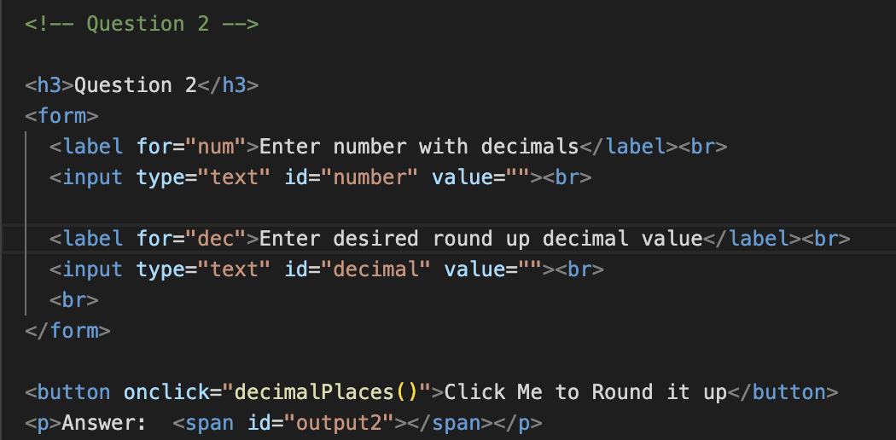

JS:

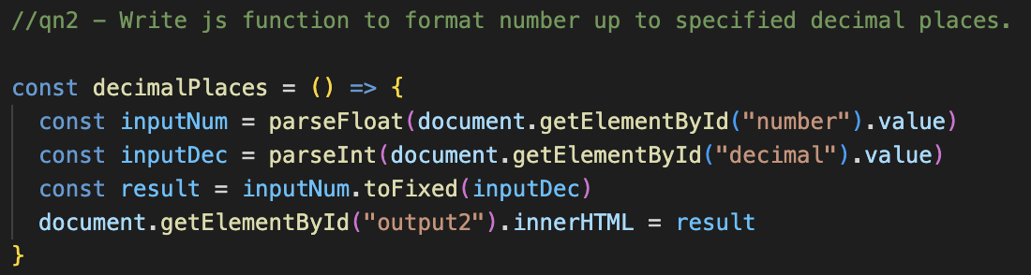

Output:

1. Check particular sub-word exist in a string or not e.g. i am learning js: 'js' exists or not

HTML:

JS:

Output:



1. Given year leap year or not (29 in Feb)

HTML:

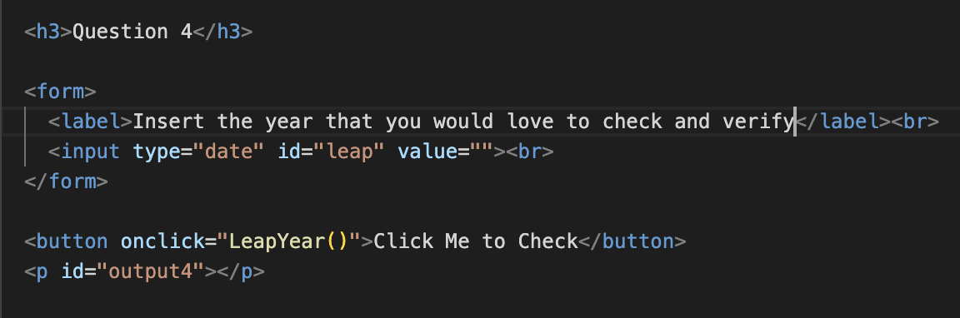

JS:

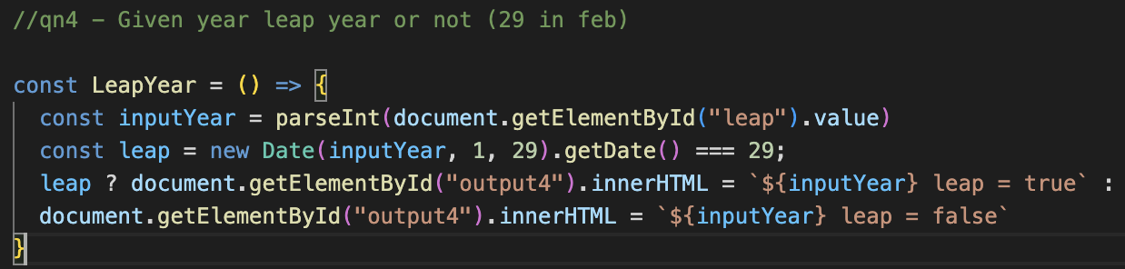

Output:

1. ATM Machine and style it

JS:

HTML:

Output:

The output transaction display will only appear if the Pin Number is correct

1. Add only even numbers in an array (array elements to be input by user)

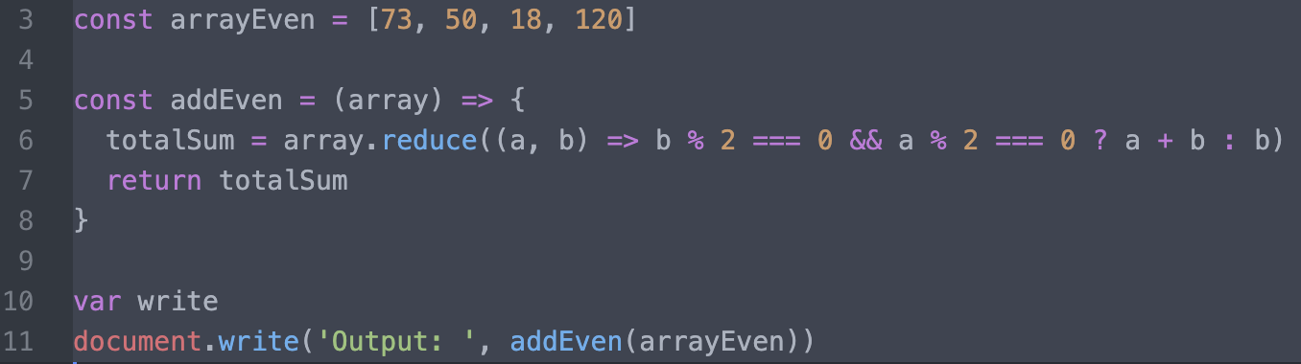

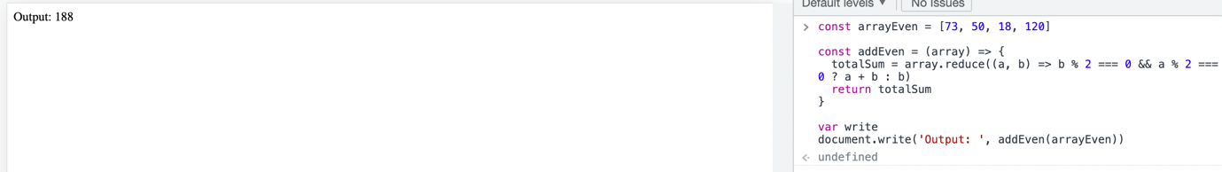

1. Biggest of even number in an array [10, 12, 90, 93, 707]: biggest even number is 90

1. Add two array [10,20,30] + [1,2,3]: [11, 22, 33]

1. Reverse an array(with loops) [10, 78, 0]: [0, 78, 10]

1. Reverse a string using loops

1. Remove duplicate items from an array [10, 50,20 67, 10, 20]: remove 10, 20

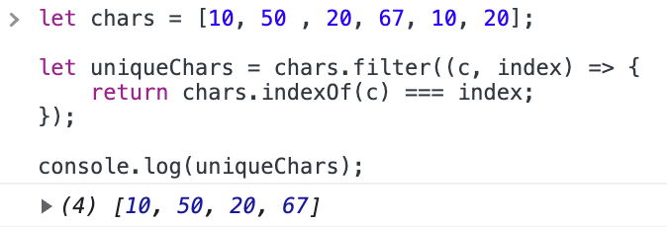

1. Remove a specific element from an array [12, 56, 89]: remove 1 element

1. Get the largest odd and even number in an array [10, 12, 900, 93, 707].

1. Take 3 inputs and structure them into objects.

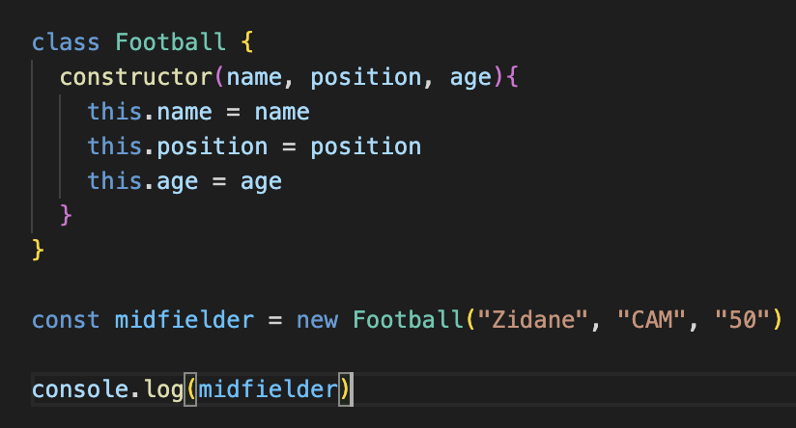

1. Create a class Car: city(),specialFeature() name, brand, color, manufacture

1. Create a class Book: type_of_book( , no. of pages, type of pages, author

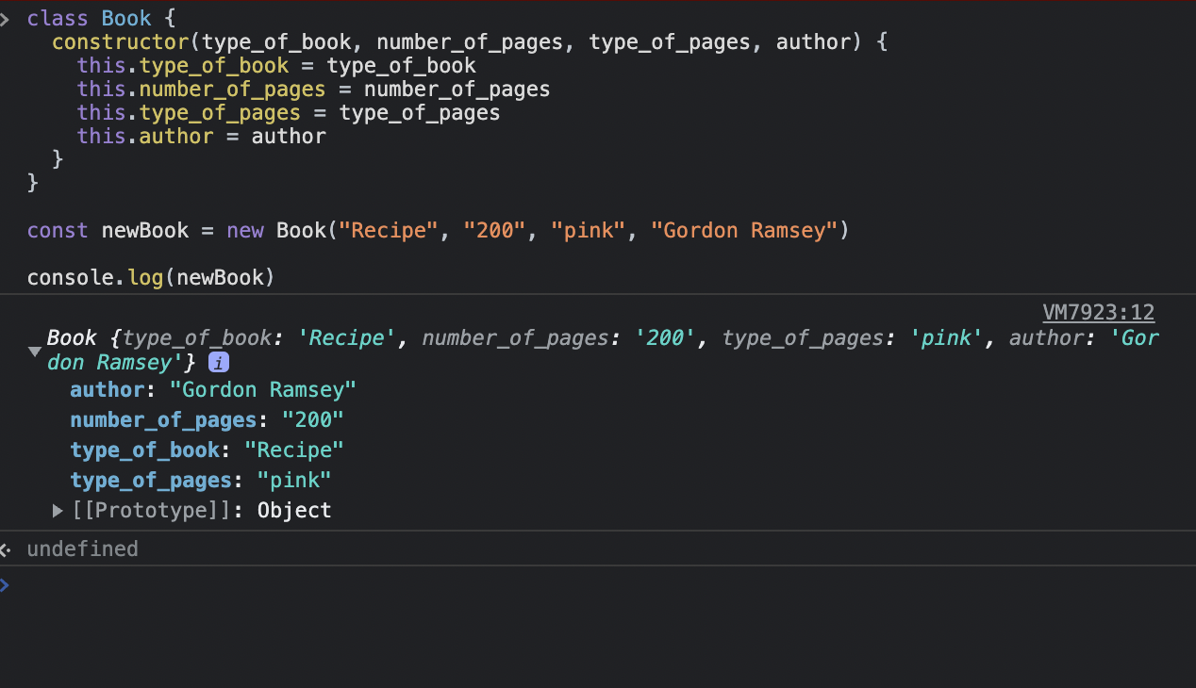

1. Create a class Animal: walk(), eat(), climb(), gender, name, disease

1. Inheritance: parent electronics (methods: name, version, company name): childclass(laptop, ipad, mobile, tablet):

class child {

configuration()

price()

}

